**Yabano**

**Hand Blender**Model: LB2104

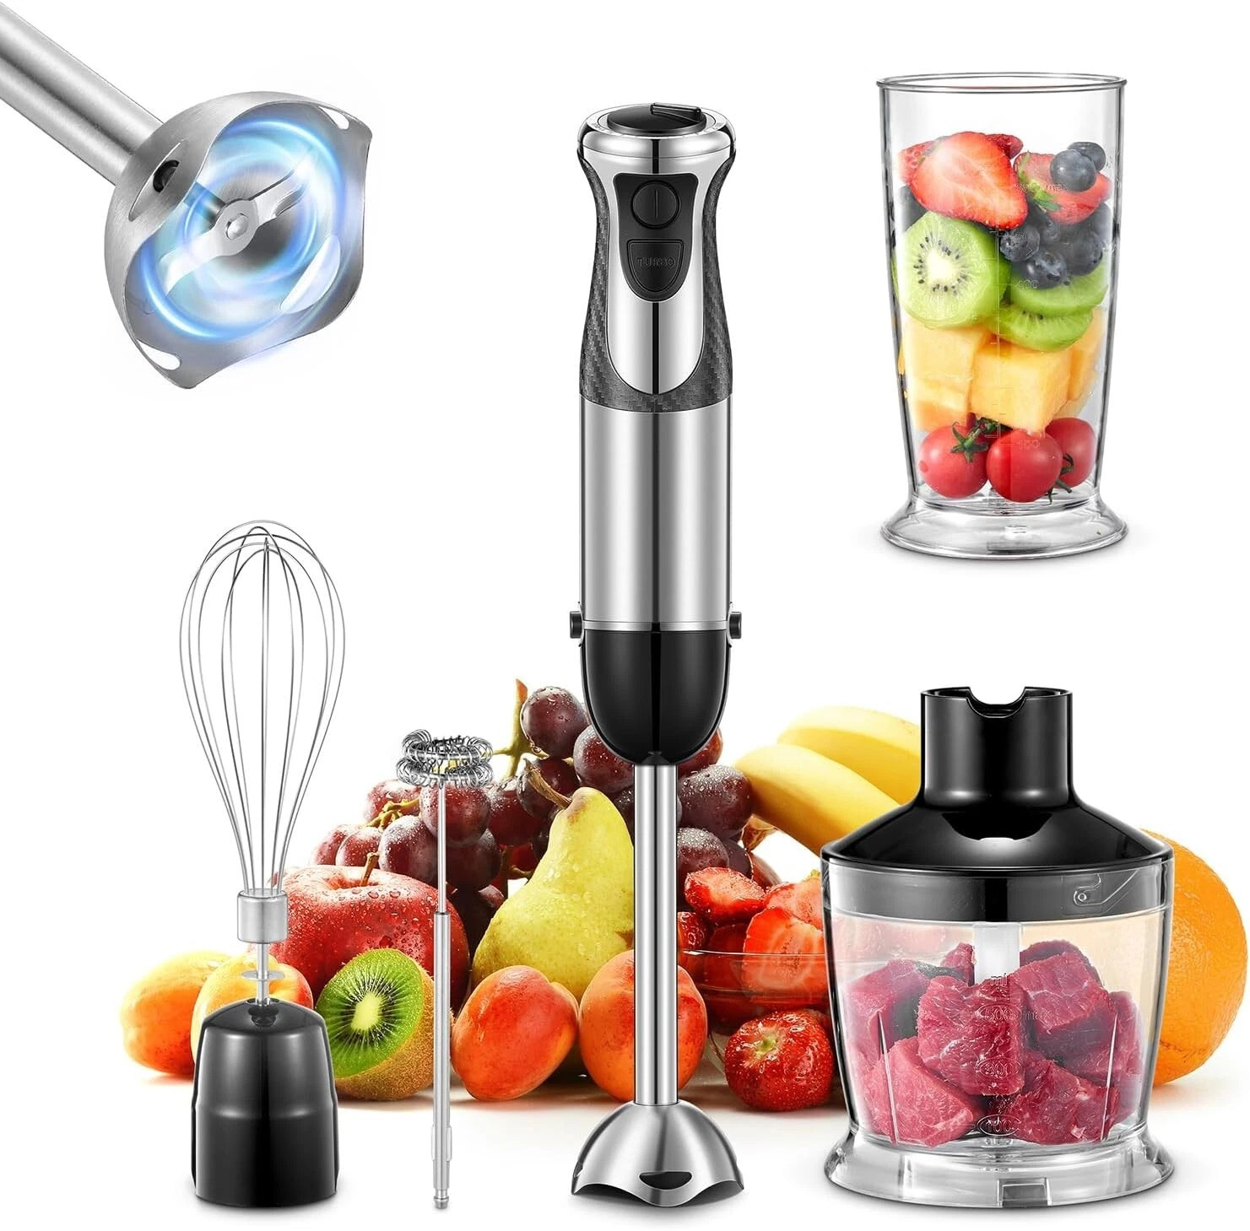

120v~60Hz 300W

Forward

Thank you for purchasing the Yabano Hand Blender. Its streamlined design makes blending and mixing a variety of foods effortless, while ensuring easy cleanup.

Parts and Installation:

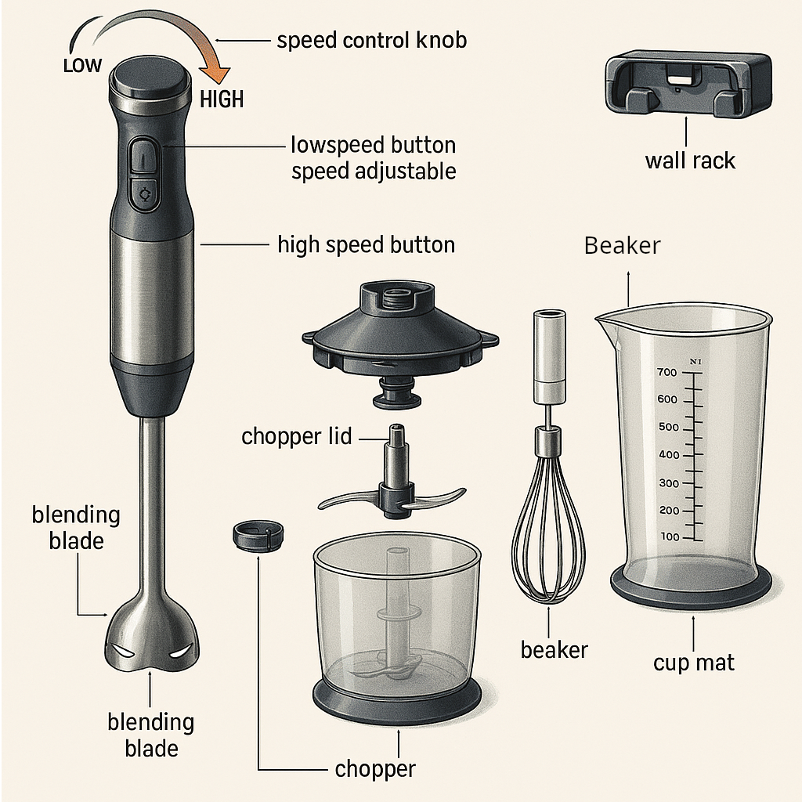

**Main Features**

1) Depending on the model, the product comes with multiple functional accessories such as a blending rod, chopper, food processing cup, whisk, beaker, potato masher, or soup blender.

2) The speed settings vary by model and are adjustable, making it convenient to process different types of food with precision.

3)The main unit and each accessory feature a turn-lock clasp design, allowing for easy attachment and use of any combination of accessories.

**Attention:**

**Continuous Use:** The accessories continuous working time should be less than 1 minute, After working 1 minute, they need to rest for 1 minute.

**Work Cycle:** Consider 1 minute at work and 1 minute at rest as a cycle. After continuously working 5 cycles, it must rest 30 minutes for motor cooling.

**Sealing Precaution:** To maintain the blending accessory’s seal integrity, avoid immersing it fully in liquids during operation.

User Instructions:

**How to use the blending blades:**

|  |  |
| --- | --- |
| **1)** This accessory is specially designed for processing dips, sauces, soups, mayonnaise, baby food, meals for older adults, as well as mixing drinks, milkshakes, and more. |  |
| **2)** Cut food into small, uniform cubes, ideally no larger than 15–30 mm on each side. Smaller pieces blend more evenly and reduce strain on the motor. Place them in the beaker and add cold/Hot water or any liquid, Then blend as needed. Place the cup mat under the beaker to prevent the beaker from slipping while blending. Add food, liquid into the beaker and blend as needed. |  |
| **3)** Plug the power cord into power socket. |  |
| **4)** The product will continue to operate while you press the high or low speed button.  For better and faster blending, hold the beaker with one hand and the main unit with the other, moving it up and down in a reciprocating motion.  To stop the blender, simply release the speed button. |  |
| **5)** Unplug the Blender unit from the power outlet when finished using. |  |

**Attention:**

**Meat:** (Max 300g): Use high speed for up to 10 seconds. For best results, use lean meat with less than 20% fat.

**Vegetables:** Use low speed for about 15 seconds.

**Rest Periods:** Always rest the appliance for 2 minutes after each use. After 3 uses, let the motor cool down for 30 minutes.

**How to use the Chopper:**

|  |  |
| --- | --- |
| This accessory is especially suitable for chopping meat, ginger, garlic, and for preparing carrot granules, chili sauce, and more. |  |
| **1)** Set the chopping Blade into the Chopping Shaft. |  |
| **2)** Cut the food into appropriate shape and size. For Example: Cut meat into 2cm x 2cm x 6cm; cut onion into 4-6 disc, etc. Put the prepared food into the chopper and lock the chopper lid. |  |
| **3)** Align the main unit with the chopper lid and secure it using the turn-lock clasp. Plug in the power cord and press the switch button to start. Release the switch button once the food is chopped to your desired size—the unit will stop automatically. Finally, unplug the power cord and pour out the processed food. |  |

**How to use the Whisk:**

|  |  |
| --- | --- |
| **1)** Insert the whisk into the egg white beating component, then lock it into the main unit. |  |
| **2)** Example: Add the egg whites of 2–3 eggs into the beaker, then place the whisk inside. Plug in the unit and press the high-speed button to begin. Once the egg whites form a foam, release the switch button to stop. Finally, unplug the power cord. |  |

**Reference Table for Using the Speed Control Function with Different Foods**

|  |  |  |  |  |  |  |
| --- | --- | --- | --- | --- | --- | --- |
| Food | Processing Size | Maximum processing / Capacity of Chopper | Maximum processing / Capacity of Beaker | Processing Time ( seconds ) | Speed Button | Speed Dial |
| Beef | 2cm x 2cm x 6cm | 300g | / | 8-10 | High | / |
| Carrot | Cut into 4 pieces | 300g | 200g + 300g  (food+water) | 40-60 | Low | 10-12 |
| Garlic | 2cm x 2cm x 6cm | 300g | / | 8-10 | High | 4-8 |
| Onion | Cut into 8-16 pieces | 500g | / | 5-10 | Low | 0-4 |
| Apple | Cut into 4-8 pieces | 500g | 200g + 300g  (food+water) | 60 | High | / |
| Egg White | / | / | 3-4 Egg Whites | 60 | High | / |
| Potato | Stewed 4-8 pieces | / | / | 60 | Low | / |

**Important Safeguards:**

To avoid the risk of electric shock or fire, use only an AC 120V power supply.

Use a dedicated socket rated for at least 6A. Do not share the socket with other electrical appliances, as this may cause overheating or fire.

Do not use hard or sharp objects, such as metal scrapers, on the product.

Always unplug the power cord after use to prevent electric shock, leakage, or fire hazards.

The product has an automatic safety shutoff when overheating. If this occurs, unplug the power cord immediately.

Disconnect the power supply before assembling, disassembling, cleaning, or when the unit is not in use.

Do not place hot food (over 60°C / 140°F) into the cup, as this may cause spills, overflow, or injury.

Use only manufacturer-recommended attachments. Using other attachments may cause injury.

Ensure all parts are properly installed and securely locked before operation.

Continuous operating time must not exceed 1 minute. After 1 minute of use, allow the motor to rest for 1 minute. One working cycle equals 1 minute of use followed by 1 minute of rest. After 5 cycles, let the motor cool for at least 30 minutes.

**The beaker, chopper, and food processor cup are not microwave safe.**

**WARNING**

Only qualified repair technicians should disassemble, repair, or modify the product. Unauthorized repair may cause fire, electric shock, or malfunction.

Keep this product out of reach of children.

Do not plug in or unplug the power cord with wet hands to avoid electric shock or short circuits.

Do not wet or immerse the main unit to avoid electric shock or short circuit.

This appliance is for indoor household use only and should not be used for commercial purposes.

**Cleaning and Maintenance:**

Always unplug the power cord before cleaning.

Do not touch the sharp blades.

Wipe the product body with a dry cloth only. Do not rinse or immerse the main unit in water.

Do not use metal brushes, nylon brushes, household cleaners, solvents, or similar abrasive materials, as these may damage the product’s surface.

Use a soft dry cloth to clean the power cord.

Follow the specific cleaning instructions for each accessory.

|  |  |  |  |  |  |
| --- | --- | --- | --- | --- | --- |
| Cleaning / Accessories | Scrubbing | Rinsing | Cleaning with Water Submersion | Dishwasher Safe | Note |
| Blending Blade |  |  |  |  |  |
| Whisk Components |  |  |  |  |  |
| Whisk |  |  |  |  |  |
| Chopper Lid |  |  |  |  |  |
| Chopper Container |  |  |  |  |  |
| Chopping Blade |  |  |  |  |  |